Loss Functions
Regression based loss
- Squared Loss: Squared Loss = 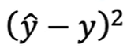
Works great for data without outliers, but for data with it ,there is
deviation from best possible result. It considers outliers.

- Absolute loss: Absolute Loss=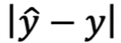
Ignores the outlier if its consideration can decrease the accuracy of model.
Support vector regression uses this loss . Gradient descent can be calculated easily .It ignores outliers.

- Pseudo-Huber Pseudo-Huber Loss=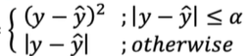
Loss: It uses the squared loss formula if there are no or low errors in
our data and uses the second formula if our data has outliers

There are various losses like Welsch, Geman-McClure, Cauchy
The best loss function can be found by using the formula,
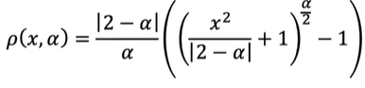
For,
$$∝$$
=2, L2 loss
=1, Pseudo-Huber loss
=0, Cauchy loss
=-2, Geman-McClure loss
=-infinity, Welsch loss

Classification based loss
- Cross Entropy Loss: Loss that occurs due to deviation in entropy

- KL Divergence: KL Divergence= H(p,q)-H(q)
/Kullback-Leibler The difference between the cross entropy and entropy is
calculated by KL Divergence.

